**Catalyst System Architecture**

# High Level Overview

Catalyst’s system architecture is designed to provide fault tolerance, system flexibility, ease of use, and ease of system maintainability. This architecture employs a distributed computer networking model which eliminates the need for a centralized switch, thus minimizing the impact of failure of any system component.

Each Catalyst system is built with one or more state-of-the-art radio gateways. These gateways are system workstations. Gateways are specific to the radio system or other communication system being supported. However, any mixture of gateways can be included to meet the customers’ specific needs. For example, a system may consist of three L3Harris Project 25 (P25) gateways, two P25 conventional or trunked Digital Fixed Station Interface (DFSI) gateways, a Long-Term Evolution (LTE) Mission Critical Push-To-Talk (MCPTT) gateway, and a Session Initiation Protocol (SIP) telephony gateway. The Catalyst architecture brings together each of these different communications gateways for dispatch and interoperability.

Each system also contains one or more of Catalyst’s Dispatch applications. The Dispatch applications are the user interface of the system. Catalyst provides our fully featured Propulsion™ public safety grade dispatch console. For customers not deploying a Catalyst dispatch console, the Catalyst IntelliLink Gateway Dashboard provides the configuration facilities needed to establish communications between LMR and LTE systems when interworking between these systems is needed. IP Soft, Desktop Dispatch and ICE™ Incident Commander Element are other application specific Console interfaces.

All components in a Catalyst system communicate via an Internet Protocol (IP) network which may be a Local Area Network (LAN) or Wide Area Network (WAN). The Catalyst portfolio has been carefully engineered to be network friendly, an advantage that should not be underestimated when comparing Catalyst to competitive solutions. The Catalyst solution provides built-in data compression algorithms, supports Transmission Control Protocol (TCP) for network control information, while using User Datagram Protocol (UDP) for voice traffic. This ensures low IP bandwidth consumption and reliability. Administrator-friendly configuration screens and standard network protocols provide ease of installation and system maintainability.

Figure 1 provides a high-level architectural overview of Catalyst’s solutions.

**Figure 1: Catalyst System Architecture Overview**

# Catalyst Advanced Gateway Technology

At the heart of each Catalyst system is Catalyst’s industry leading gateway technology. Unlike our competitors’ gateway products, a Catalyst gateway is far more than a mechanism for converting analog voice into IP packets and vice versa. Catalyst’s gateways perform a host of functions to meet the extreme requirements of critical communications.

Catalyst offers gateways that support both **wireline** and **wireless** system interface connections, and the two can be combined to provide the optimal solution for each unique agency.

Catalyst’s **wireline** system interface connections include the P25 standard Digital Fixed Station Interface (DFSI) and Console Subsystem Interface (CSSI) that are connected directly into various manufacturers’ P25 radio systems, Digital Mobile Radio (DMR) Association standard wireline interface called the Application Interface Specification (AIS) which is connected directly into various manufacturers’ DMR radio systems, and the 3GPP standard Mission Critical Push-To-Talk (MCPTT) interface - all via an ethernet connection. Other **wireline** solutions are Catalyst’s SIP gateway for an ethernet interface to SIP telephony equipment, and Catalyst’s PSTN gateway which provides an RJ11C connection to a “plain-old-telephone-system” line.

Catalyst’s **wireless** system interfaces require a connection to a donor radio (or control station) which provides an interface to all radio systems, channels, and talk groups programmed into that radio. Many of Catalyst’s gateways provide intelligent control of the donor radio such that channel change, caller ID, emergency calls, GPS location data and other features are also made available at the dispatch console and other end user devices connected to the Catalyst system. These advanced features are provided for DMR, P25 Trunked, P25 Conventional, NXDN Trunked, NXDN Conventional, MDC1200, EDACS, FleetSync, and others.

# Summary of Wireline Gateway Types

## P25 Console Sub-System Interface (CSSI) - IP|CSSI™

Gateway software that provides a direct ethernet interface to a P25 switch infrastructure via that manufacturer’s CSSI gateway. Multiple simultaneous audio paths can be routed through the Catalyst CSSI gateway to provide a more robust solution versus donor radio scanning. The gateway supports advanced features like console priority (pre-empt) and emergency calls.

## P25 Digital Fixed Station Interface (DFSI) - IP|FSI™

Gateway software that provides a direct ethernet interface to P25 conventional base stations, providing P25 digital or analog audio, and control for ID’s, emergency indication, channel changes and other advanced control features.

## DMR Application Interface Specification (AIS) - IP|AIS™

Gateway software that provides a direct ethernet interface to Tier III DMR trunked switch infrastructure via that manufacturer’s AIS gateway. Multiple simultaneous audio paths can be routed through the Catalyst AIS Gateway to provide a more robust solution versus donor radio scanning.

## Session Initiation Protocol (SIP) - IP|SIP™

Gateway software for a console interface to a VoIP telephony path or SIP PBX system through a SIP ethernet interface.

## LTE Mission Critical Push-To-Talk (MCPTT) – IP|MCPTT™

3GPP MCPTT-compliant gateway software that provides connectivity to one or more MCPTT talk paths. Catalyst’s IP|MCPTT gateway appears to the host MCPTT system as an end-user client, enabling interworking of MCPTT talkgroups with Land Mobile Radio (LMR) talkgroups/channels, and with the dispatch console.

# Summary of Wireless Gateway Types

Catalyst’s advanced wireless gateways provide simple interfaces with a variety of trunked and conventional radio systems from multiple manufacturers and can provide advanced features like Unit ID’s and emergency calls. They employ two connections to the donor radio or control station. Those are two or four wire audio connections (analog or digital) which are converted to UDP packets, and a serial connection which is converted to TCP packets. UDP is an effective and bandwidth efficient method of sending voice information, however, in critical communications TCP is required for command and control of the donor device. TCP signaling provides bidirectional communication to ensure the donor device and Catalyst system stay synchronized.

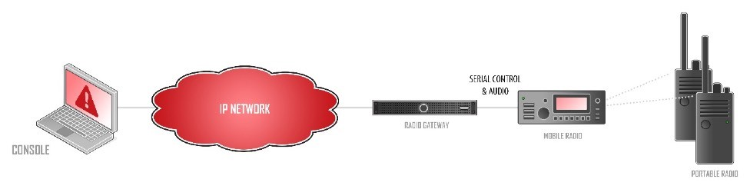

## IP|Radio™

Gateway software for L3Harris Trunked and Conventional P25, EDACS, and Analog

Conventional solutions providing, when available, Unit ID’s, emergency calls, call scan and direct access to hundreds of channels or talkgroups. M7300 (XG-75M), M5300, Unity (XG-100M), and the XL-200M series donor radios also provide digital rather than analog audio.

## IP|Fleet™

Gateway software for Kenwood P25, LTR Trunking, FleetSync, NXDN Trunked and Conventional, and MDC1200 providing Unit ID’s, emergency calls, call scan and direct access to hundreds of channels or talkgroups. Contact Catalyst for details regarding the specific donor radio and over-the air protocol of interest to your organization.

## IP|Tone™

Gateway software for most Tone Control repeaters and mobile radios. Tone control can provide limited channel change.

**Network Access Radio™**

Gateway software for simple 4-wire audio with a DC control PTT connection to a repeater or mobile radio.

# Benefits of Catalyst’s Architecture and Advanced Gateways Technology

* Our Peer-to-peer architecture makes the system easily expandable to many gateways and many dispatch clients. It is an end-to-end IP design from the outset.
* Advanced Audio Flow Control. Many of the Catalyst gateways monitor each radio system and can tell when a talk channel has been assigned. If a gateway receives audio from a dispatcher or another gateway while waiting for a talk channel, it will buffer the audio until a channel is available for transmission. This ***dynamic*** buffer ensures that the entire audio sequence has been transmitted without clipping.
* System optimization: Gateways are designed specifically for the system to which they are connected. For example, an IP|Radio gateway is designed specifically for support of L3Harris P25 and EDACS radio systems.
* Scalability: Catalyst solutions can grow and evolve to meet your agency’s changing needs. For instance, if an agency upgrades to a Project 25 radio system, the P25 CSSI gateway can be added to an existing system. Likewise, the DMR gateway can be added to an existing system. Adding new LTE services including FirstNet® built with AT&T or Southern Linc’s CriticalLinc™ MCPTT services is likewise easily added to an existing system by adding an IP|MCPTT gateway.
* Local recording: With the recording feature, all audio transmissions are stored on each gateway and can be recalled from any console.
* Network efficiency: The system is extremely IP network bandwidth efficient with the choice of various audio compression algorithms from uncompressed 64 kbps down to 10 kbps per audio path, without impacting audio quality.
* Reliability: Catalyst gateways that are placed in a patch by a dispatcher communicate directly with each other. In fact, the console used to create the patch could be removed from the system and the patch would remain in operation. Unlike competing systems where all audio passes through the central console, Catalyst’s distributed architecture and advanced gateway technology does not require an operational console, and significantly reduces bottlenecks at the console for systems deployed with such.

**Catalyst Console Clients**

**Propulsion™**

Propulsion™ is a modern dispatch system for LMR and LTE radio systems designed to meet the stringent reliability requirements of Public Safety, Utility, Education, and Transportation dispatch applications. Propulsion is designed from the ground up as a fault tolerant hardware and software solution providing ease of use and maintainability, with vast flexibility and functionality. The Propulsion console operates on a standard Windows-based PC workstation, providing Voice over IP dispatch to various communication networks in concert with the gateways. Operating on a shared or dedicated IP network, the consoles may be located anywhere on the network.

Propulsion’s touch screen compatible, highly configurable user interface displays Unit ID’s, emergency calls, and call history. Dispatchers can simulselect or patch up to eight channels with intuitive graphical controls, instantly transmit on each module, uniquely set the volume for each module, differentiate audio on select and unselect speakers, and replay recent calls with a single click. Each agency can add custom graphics to accelerate recognition of who is talking.

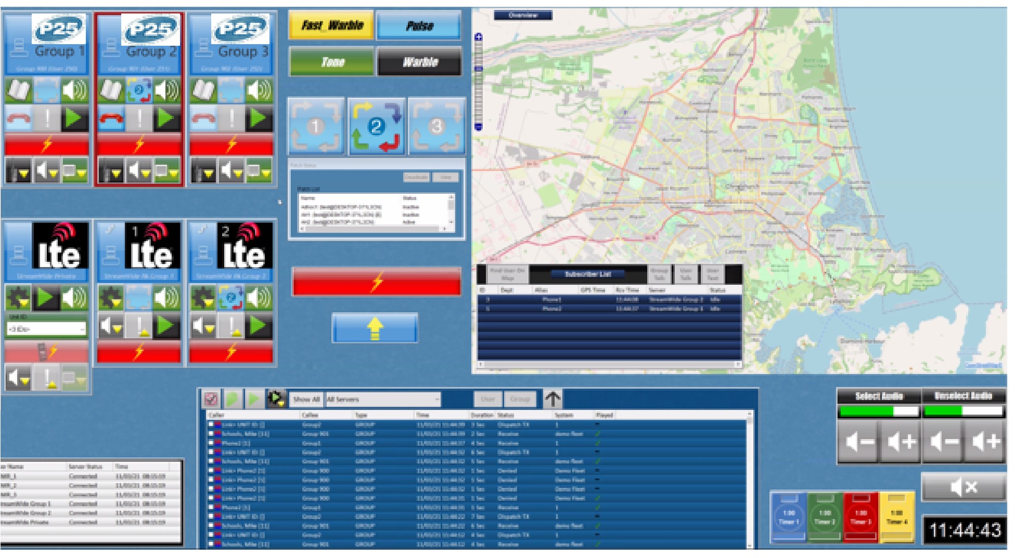

## IntelliLink™ Gateway Dashboard

Intellilink Gateway Dashboard (IGD) is a flexible Interworking solution that links multiple talk groups or channels between different Land Mobile Radio systems and Mission Critical Push to Talk groups on LTE networks including FirstNet® built with AT&T or Southern Linc’s CriticalLinc™ MCPTT services. IGD provides enhanced graphics and control for radio voice communications that are essential for fireground, emergency medical, special rescues, utility restoration, and other public safety and critical infrastructure incidents.

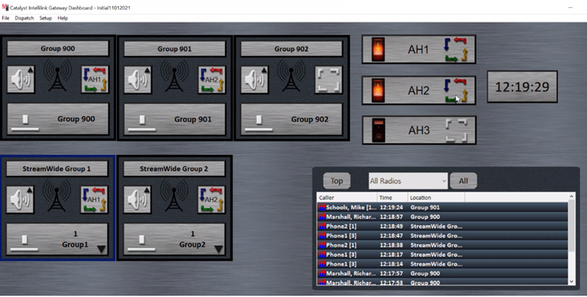

**Summary**

The Catalyst Architecture is unique in the marketplace by using workstation computers at both the Dispatch Console and Radio Gateway interfaces. By moving much of the processing power to the Gateways instead of at the Console as most competing dispatch systems do, single points of failure are eliminated and bandwidth efficiencies are achieved. If a connection between a Dispatch Console and Gateway is interrupted, for example, patches between different radio systems and recorded audio is still maintained.

Contact Catalyst for more information and a design and demonstration of how Catalyst’s IP architecture can benefit your organization.